Algorithms Exp 3

Task: Finding the kth smallest and the kth largest element in a random array of 1000000 elements and compare them

Kth smallest:
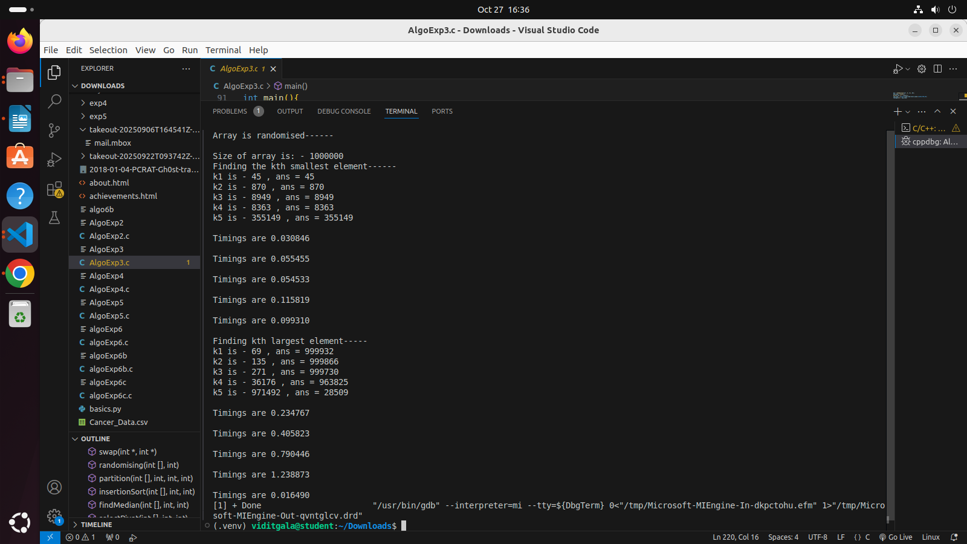

Kth largest:

